1. login

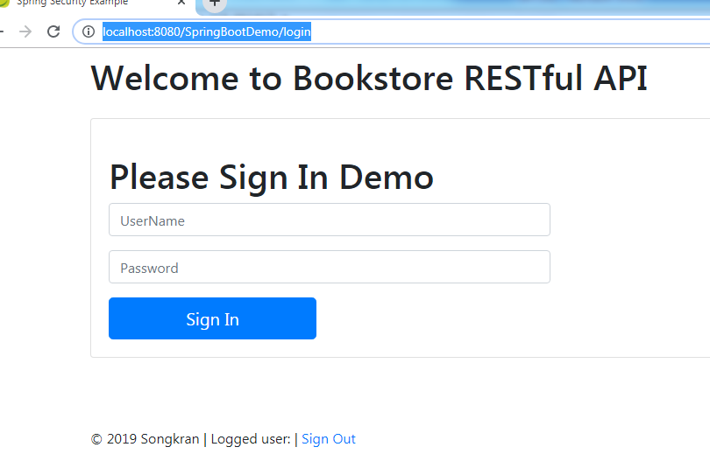

2.showns menu

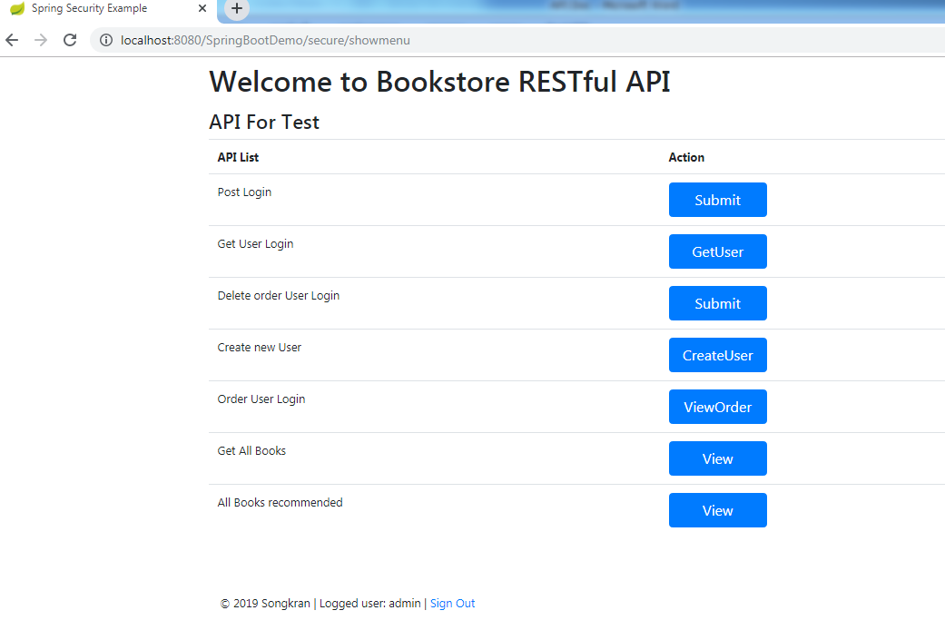

3. click menu for test on screen

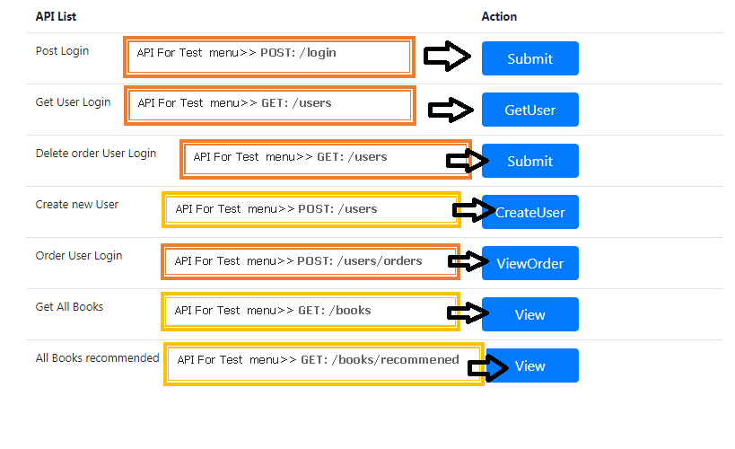

4. click Post login

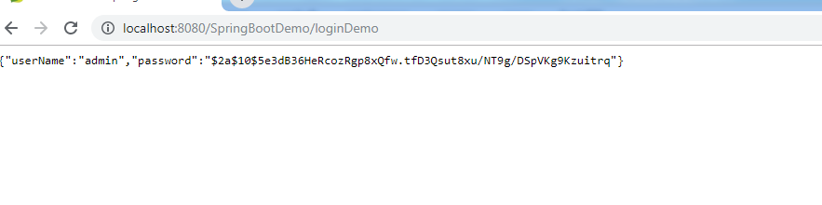

5. click get User Login

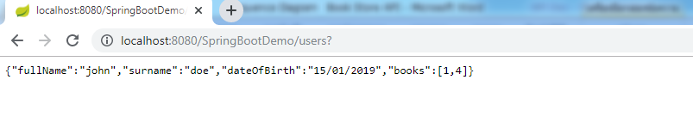

6.Delete Order User Login

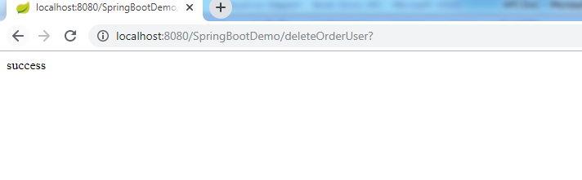

7.Create New User

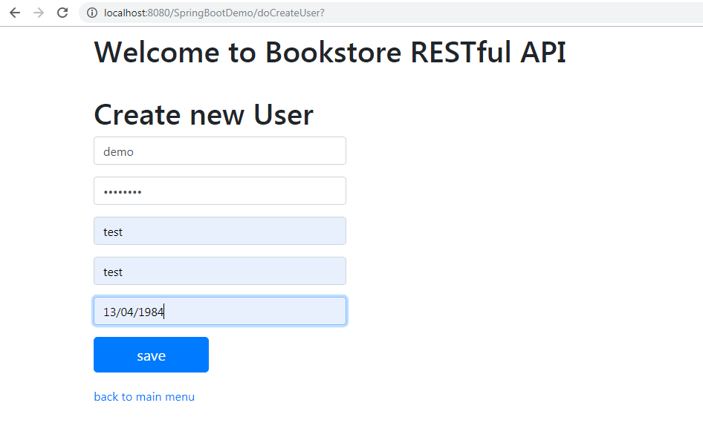

click save

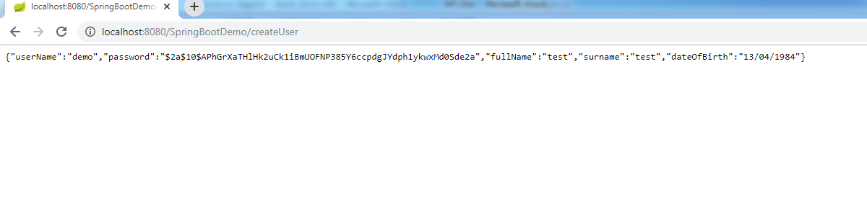

8.Order user Login

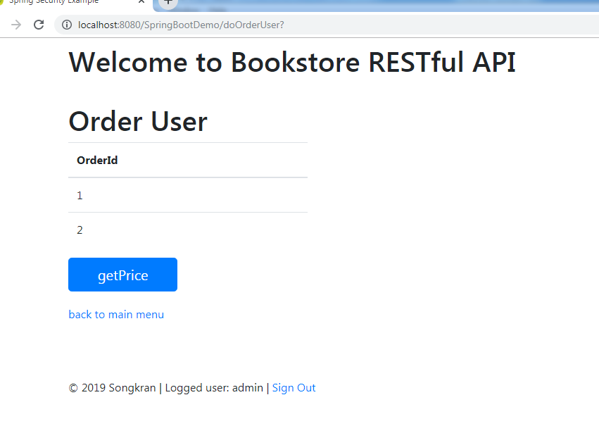

click getPrice

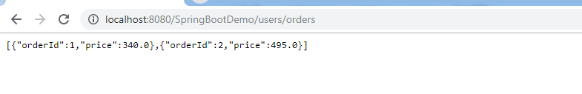

9.Get All Books

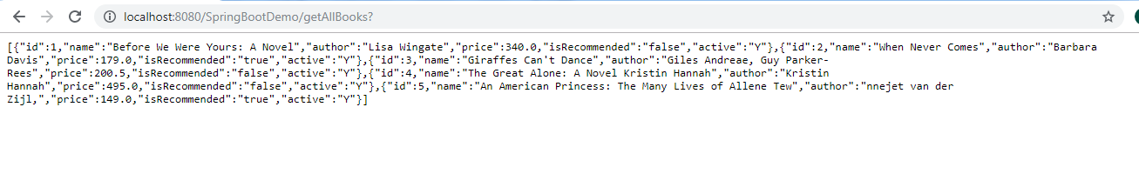

10.Get All Books recommended

